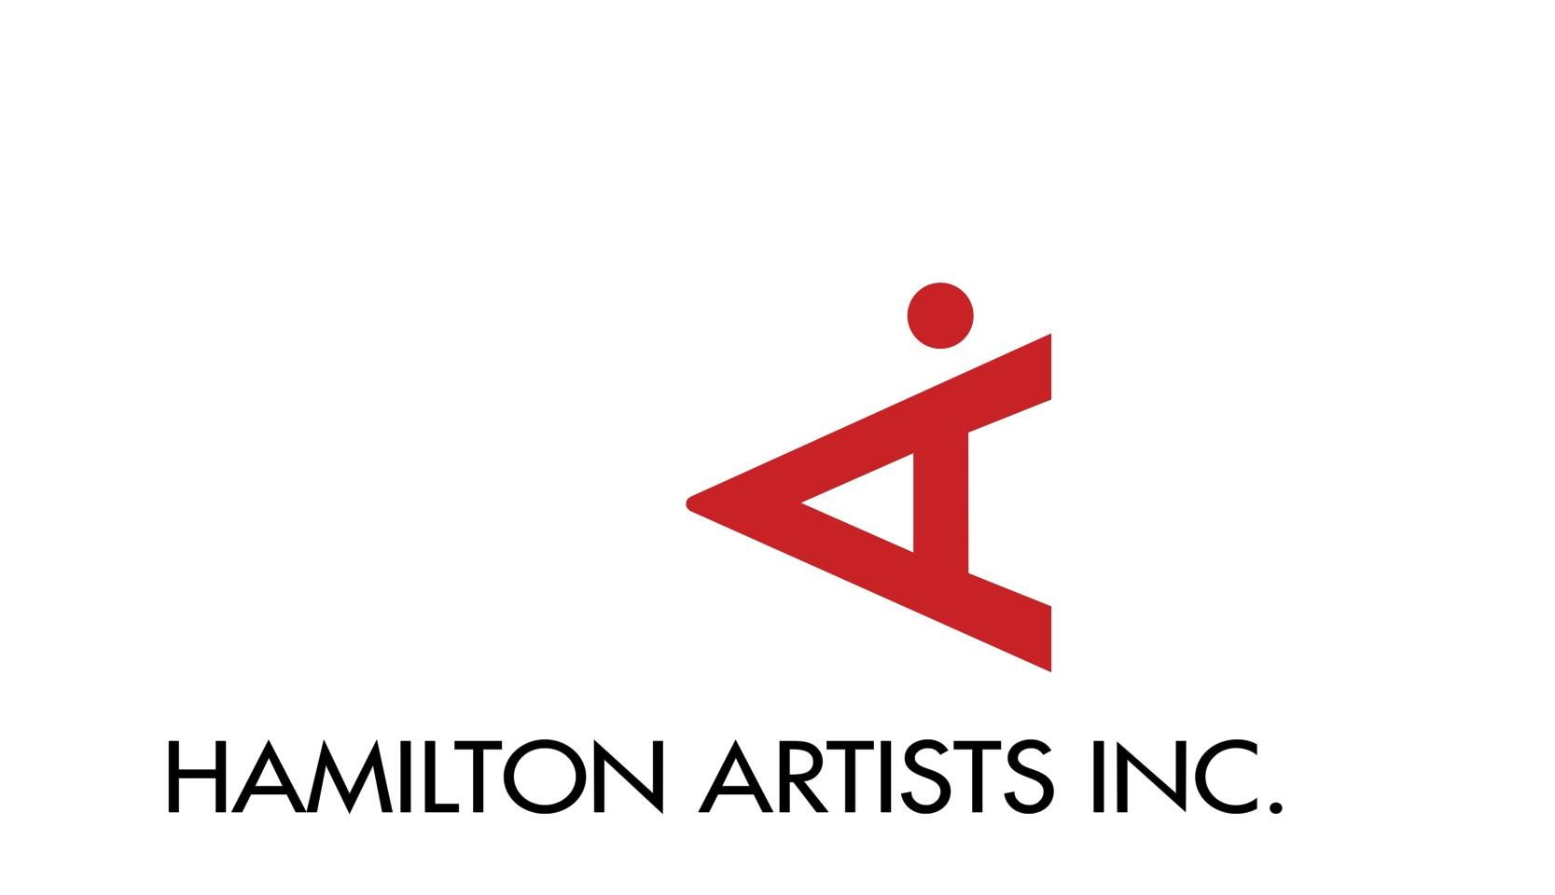
Incoming!
A Project for newcomer, immigrant, and refugee artists
Art Exhibition Dates: May 25 – June 12, 2021
Application Deadline: March 26, 2021

Hamilton Artists Inc. is pleased to present Incoming! a project addressing needs of newcomer, immigrant and refugee artists. Incoming! includes free workshops, events, and an art exhibition in spring/summer 2021 supporting visual artists who are new to Canada. The art exhibition will include 5 artists exhibited in window spaces around Hamilton, taking place from May 25 - June 12, 2021. The exhibition will present work by artists who were born and/or lived outside of Canada, and now want to establish themselves in the Hamilton art community.
We are asking artists to submit their artwork for consideration. Please note that selected artists must be able to adapt their work to be shown as a window display. This could include reproducing original artwork as large format prints, printing costs to be covered by the Inc. Window sizes and locations will vary. The artists selected for the exhibition will be paid an artist fee. Notification can be expected in April 2021.
Application Requirements:
- Application Form (this document), fully completed
- 5-10 images of your artwork (labeled as 01_LastName, 02_LastName, etc.)
- Artist CV or Resume (optional)

Please send your application form and images to selections@theinc.ca with the subject line “Incoming Application.” The deadline for submissions is March 26, 2021.
If you have any questions or need help with your application, please email Jasmine Mander at community@theinc.ca or call 905-529-3355.

Visit: www.theinc.ca
Instagram: @hamiltonartistsinc
Facebook: Hamilton Artists Inc
Twitter: @hamartinc

Personal Information

_____________________________________________________________________________________
Full Name
_____________________________________________________________________________________
Address
_____________________________________________________________________________________Postal Code City Province Country
_____________________________________________________________________________________
Your Website, Facebook, Instagram, Twitter (optional)

Tell us about yourself or insert your artist biography (150 words)
Tell us about your art practice. (150 words)
How do you make your pieces? What ideas do you explore in your artworks?

List of Works
Please include 5-10 photos of your work and complete the chart below with artwork details.
# | Title | Material | Size | Year
1
2
3
4
5
6
7
8
9
10

