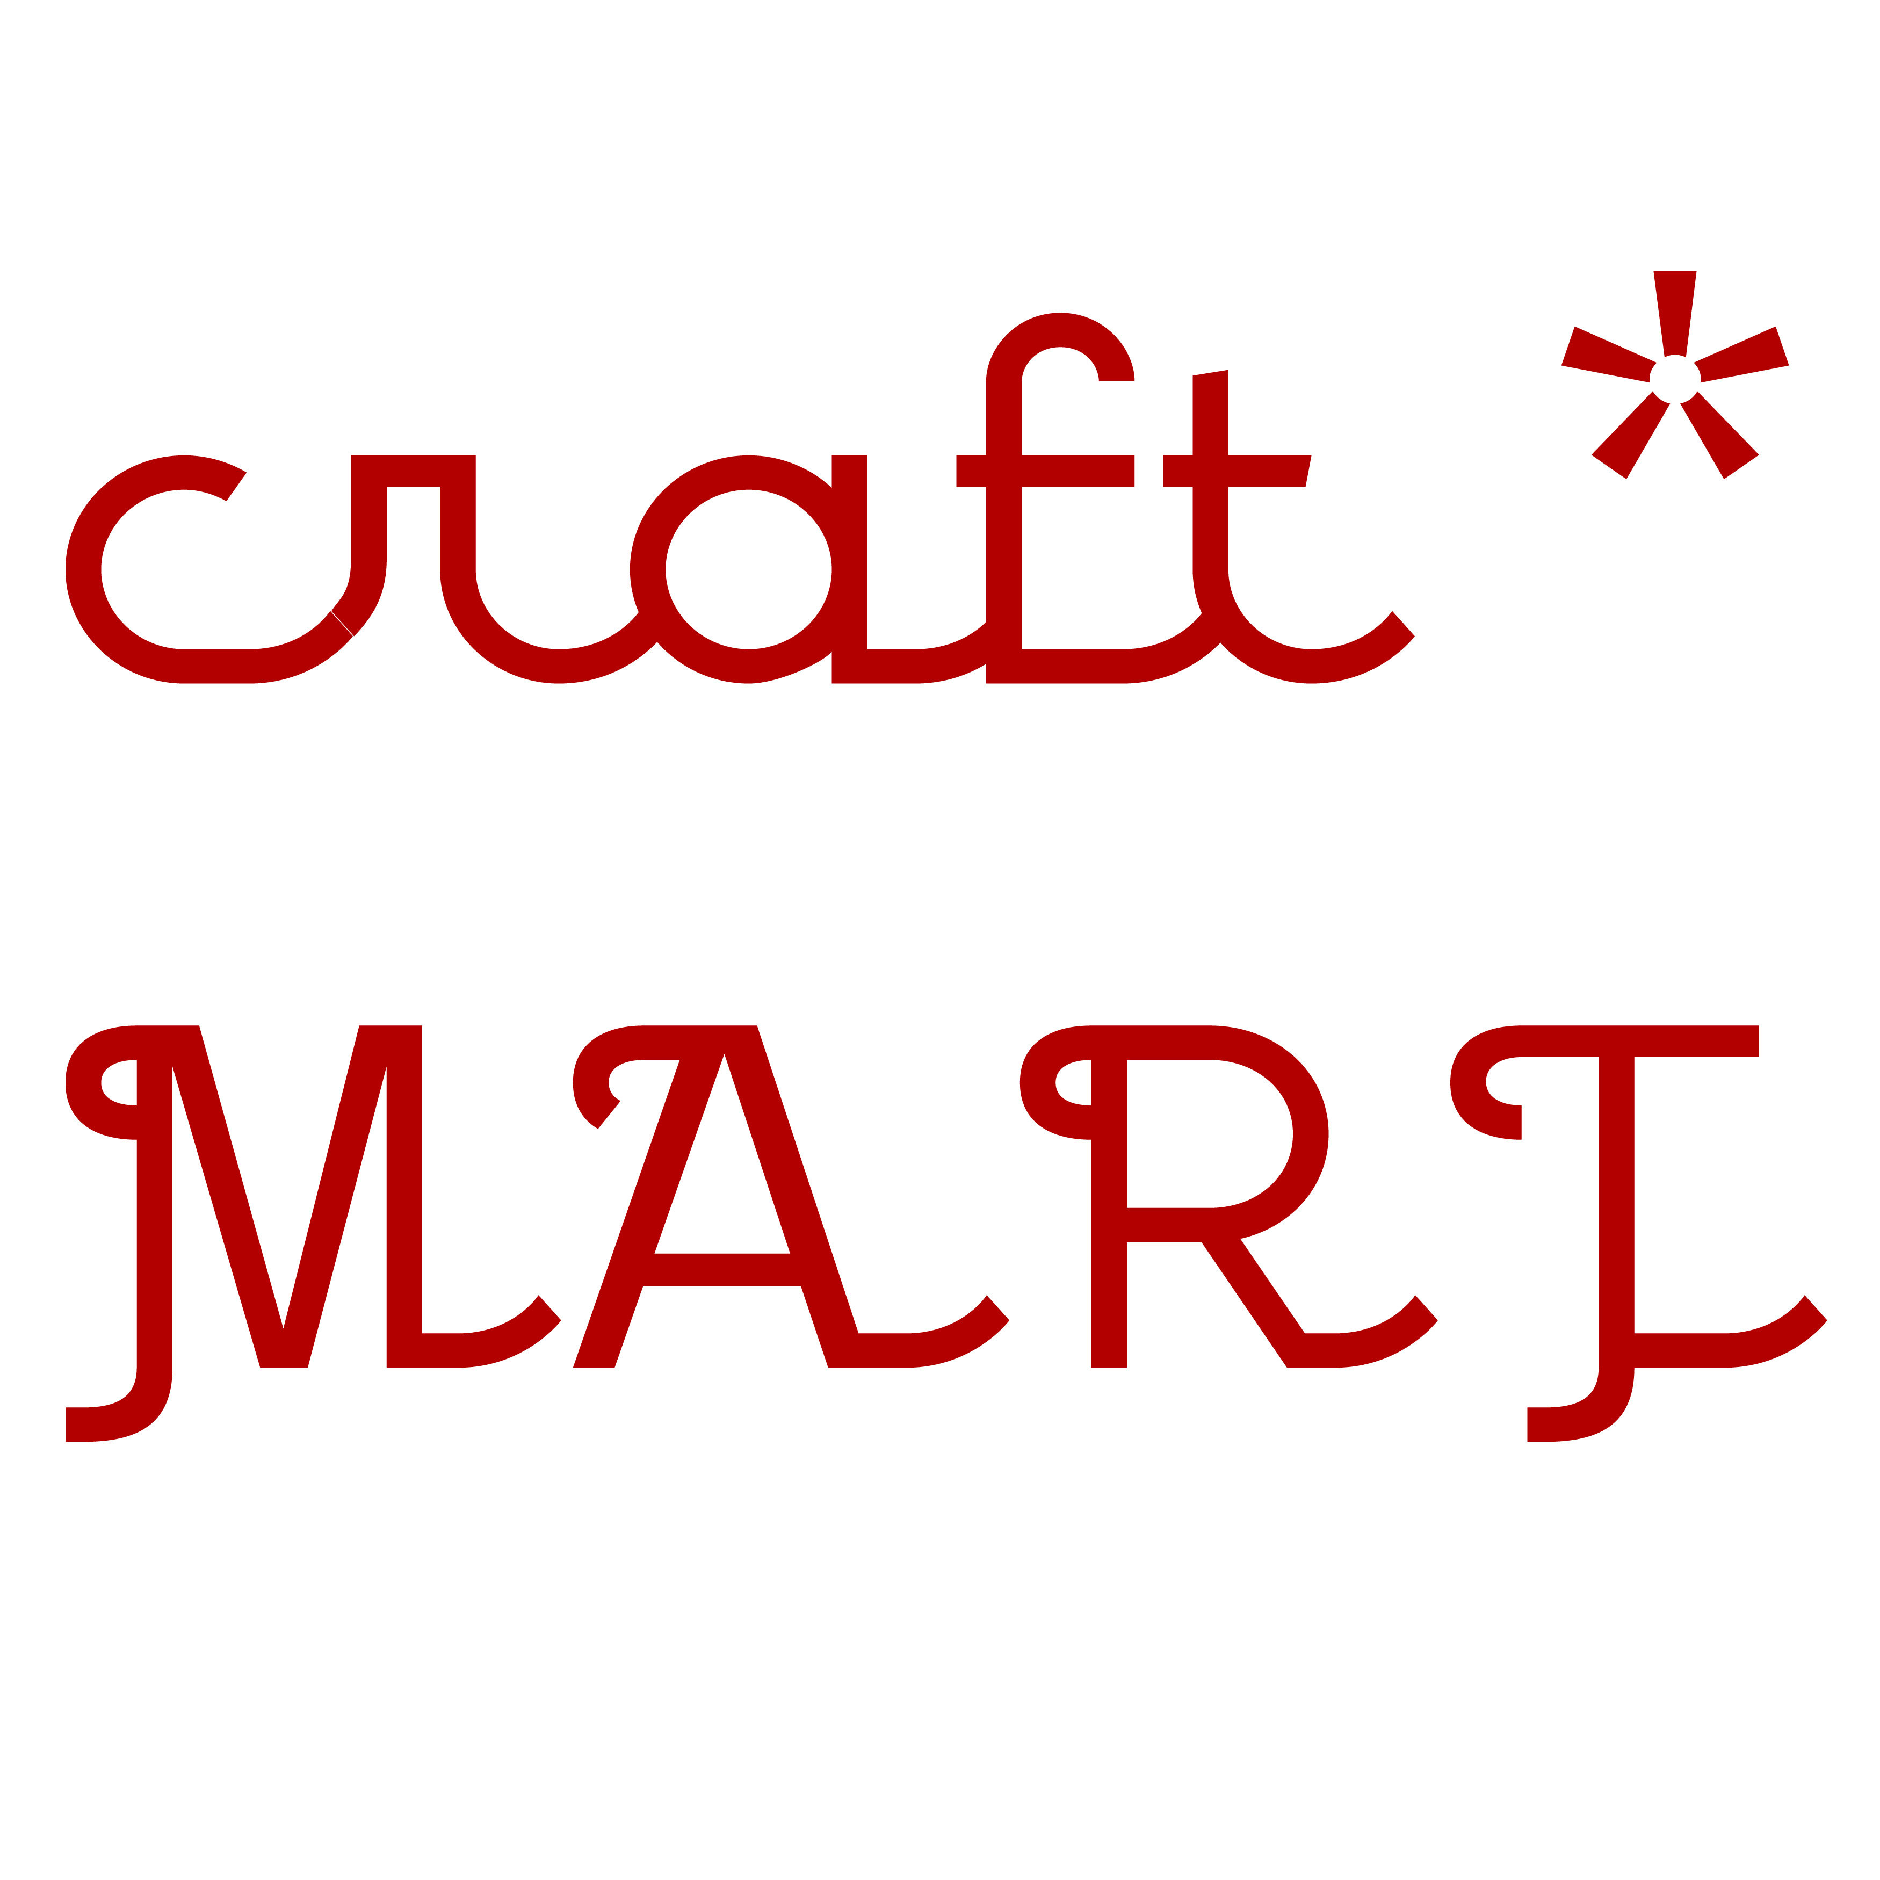 Craft Mart Application 2015

Hamilton Artists Inc., Hamilton ON.
Friday, December 11 (during Art Crawl), 6-10 pm
Saturday, December 12, 11 am - 5 pm

Craft Mart is a curated pop-up craft and design market that hosts talented and avant-garde makers. Located at the Hamilton Artists Inc. on the corner of James and Cannon, Craft Mart will be open to the public during an Art Crawl weekend, with an expected 2000-2800 visitors.

Please submit a completed application by September 14th at midnight to events@theinc.ca including:

- Application Form
- Support images: 3-5 jpeg images of your work and/or links to submit your website for review.
- Product Descriptions: Tell us about the work you intend to sell. How was it made? What makes it unique? What are the price points? These descriptions will help us market your work as we advertise the event.
- Biography: Tell us about yourself and your practice. This information may be used to market the event.

Details

Craft Mart is an annual event hosted by Hamilton Artists Inc. Its aim is to bring together the talented work produced by crafters and designers from around the region.

Why is Craft Mart unique and why should I apply? Craft Mart is a great opportunity to showcase hand-made and uniquely designed craft and design in a large indoor venue during Art Crawl. As a contemporary art gallery, our space is designed to make your work the focus. You should apply because we will bring together an impressive collection of crafters and designers that reflects our dynamic and diverse community.

How much are the vendor fees? The cost to participate is $150.00 payable upon acceptance. The fee guarantees you a table (2' x 6') and 1 chair for both days, as well as printed and online promotion, and e-material for self-promotion. The fees collected by The Inc. cover the costs of Craft Mart with all additional proceeds directed towards gallery programming. Please note that there is no application cost or commissions from sales. Vendors requiring Wi-Fi access will be charged an additional $10.00.

Can I apply if I'm not from Hamilton? Yes, absolutely.

How are vendors selected? Vendors are selected through a jury composed of The Inc. staff and local guest jurors. The jury process is by consensus. Decisions are based on uniqueness, quality and the distribution of space by goods or category.

How many vendors will be participating? We are seeking 24 vendors in total.

Where do I send my application? Please send your application to events@theinc.ca

What do I do when I am accepted? After hearing from us, you will need to confirm acceptance by returning a signed contract and paying your vendor fees within 10 days. After 10 days we will contact vendors on our wait list.

Regarding Cancellations: Once accepted and payment submitted your participation fee is non-refundable.
NSF fees will apply for returned cheques.

What does the space look like? The Inc. has an attractive glass foyer that is fully wheelchair accessible and leads into our two contemporary galleries. We are located on a busy intersection in downtown Hamilton at Cannon and James St. N with a great deal of foot traffic and nearby parking.

The gallery has clean walls and track lighting. Each vendor is required to bring their own table dressing, and décor.

Can I share a table or days with another vendor? Sorry, no and no. Collectives and businesses applying are considered one applicant. Accepted vendors must attend both Craft Mart days.
Collectives and businesses, please note that for space reasons please only send a maximum 2 people.

When is the deadline? Send in your applications by Monday, September 14, 2015 midnight.

When will I hear from you? We plan to contact accepted vendors by October 2, 2015.

Craft Mart 2015 Application Form

Contact Information

1. Full name
2. If applicable include Company Name
*please note that Company Name will be used in promotion*
3. Website
4. Mailing Address

5. Email
6. Phone Number

About Your Work and You

1. Provide a detailed description of what you create. 250 word max

2. Briefly, list your type of goods. (i.e. jewellery, children's apparel, etc.)

3. For promotional use, please provide a 100 word max. description/bio (optional)

4. Attach 3-5 digital images of your work. Keep files under 500k. Be sure to include details for each image here or as part of the title.

5. Logo? Send it too!
6. Price range of goods
7. Is there anything else you would like to tell us (spatial requirements, etc)?

Acceptance & Payment

1. I have read and understand the details.

YES

2. I agree to process my payment via paypal or cheque 10 days after acceptance.

YES

3. I agree to present and sell the same goods as described in my application.

YES

Vendor name

