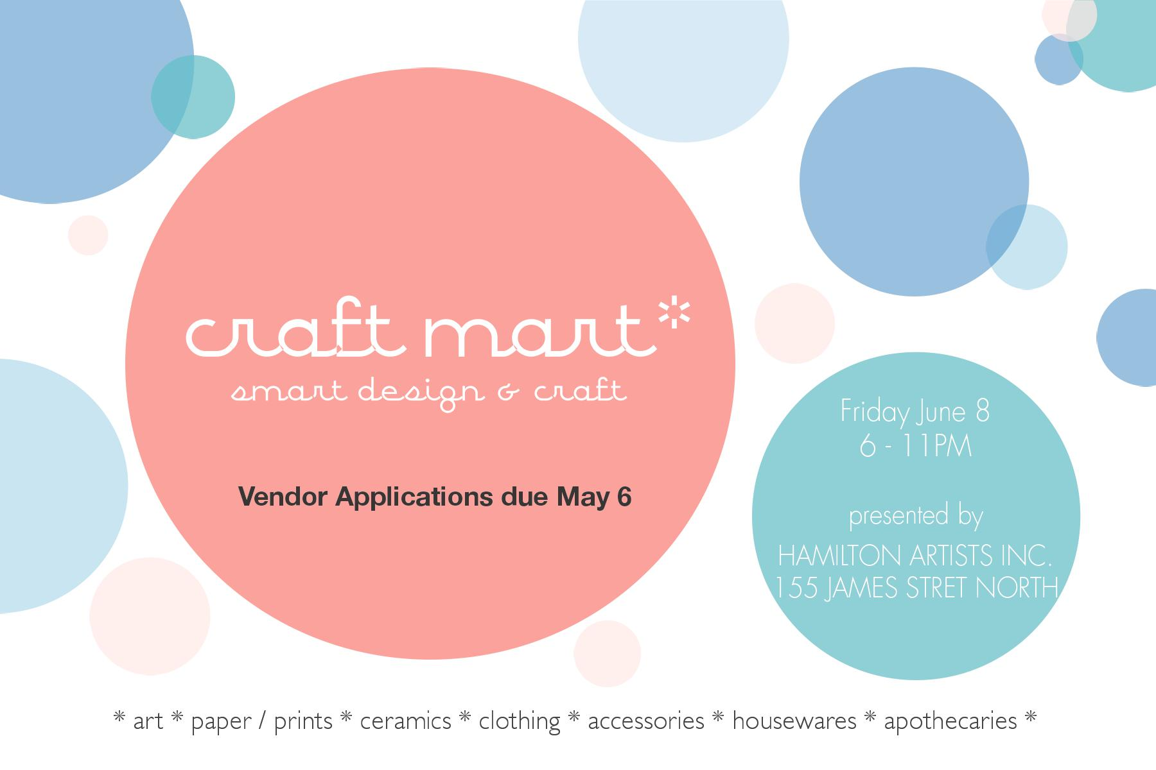

Application Information

Hamilton Artists Inc., 155 James St. N. Hamilton ON.

Friday, June 8th (during Art Crawl), 6-11 pm

Hamilton Artists Inc. is excited to announce a call for applications for its annual Spring Craft Mart taking place June 8th 2018. Since its launch in 2013, Craft Mart has grown into a community-building event that brings a carefully curated collection of independently produced Canadian Art, Craft + Design to the people of Hamilton. We are calling all artists, crafters, artisans and designers to apply to be a part of this indoor market.

Craft Mart will be open to the public during the Art Crawl, annual attendance of 2500 visitors

Please submit a completed application by May 6th at midnight to [events@theinc.ca](mailto:events@theinc.ca) including:

* Application Form (located at the end of this document)
* Support images: 3-5 jpeg images of your work + links to your website and social media for review.
* Product Descriptions: Tell us about the work you intend to sell. How was it made? What makes it unique? What are the price points?  These descriptions will help us market your work as we advertise the event.
* Biography (150 words): Tell us about yourself and your practice. This information may be used to market the event.

The Details

Craft Mart is an annual curated art & craft show hosted by Hamilton Artists Inc. Its aim is to bring together the talented work produced by artists, crafters and designers from across the region and beyond. Since its inception in 2013, Craft Mart has grown into a highly anticipated market showcasing some of the best makers from across disciplines.

As a nonprofit artist run centre, with charitable status, it is one of our main fundraising events of the year. Revenues support gallery programs and operations.

Craft Mart Application Form

Contact Information:

1. Name and Company Name (if applicable):

*please note that Company Name will be used in promotion*

2. Website:

3. Social Media:

4. Mailing Address:

5. Email:

6. Phone Number:

About You and Your Work:

1. Provide a detailed description of what you create. (250 word max)

2. Briefly, list the type of goods you sell. (i.e. jewellery, children's apparel, etc.)

3. Indicate price range of goods

4. For promotional use, please provide a 150 word max. biography

5. Attach 3-5 digital images of your work. Use separate jpgs and keep files under 500k. Be sure to include details for each image here or as part of the title.

5. Logo? Send it too!

7. Is there anything else you would like to tell us (set up requirements, etc)?

Acceptance & Payment

1. I have read and understand the details. YES

2. I agree to process my payment via paypal or cheque 10 days after acceptance. YES

3. I agree to present and sell the same goods as described in my application. YES

**FAQ**

Why is Craft Mart unique and why should I apply? Craft Mart is an excellent opportunity to showcase your hand-made and uniquely designed art, craft and design to thousands of visitors, in a gallery setting during Art Crawl. As a contemporary art gallery, our space is designed to make your work the focus.

How much are the vendor fees? The cost to participate is $100.00 payable upon acceptance.  The fee guarantees you a table (2' x 6') and 1 chair, as well as printed and online promotion, and e-material for self-promotion.  Vendors are required to bring their own table dressing and décor.  The fees collected by The Inc. cover the costs of Craft Mart with all additional proceeds acting as fundraising revenue directed towards gallery programming.  Please note that there is no application cost or commission from sales. Wi-Fi is available for a fee of $10.00.

What does the space look like? The Inc. has an attractive glass foyer that is fully wheelchair accessible and leads into our two contemporary galleries as well as an outdoor community courtyard.  We are located in the heart of the cultural district of James Street North at the intersection of James and Cannon streets. The gallery has clean walls and track lighting.

Can I apply if I'm not from Hamilton? Yes.

How are vendors selected? Vendors are selected through a jury composed of Inc. committee members, staff and local guest jurors. The jury process is by consensus. Decisions are based on uniqueness, quality and the distribution of space by goods or category.

How many vendors will be participating? We are seeking 18 vendors in total.

Where do I send my application? Please send your application to [events@theinc.ca](mailto:events@theinc.ca)

What do I do when I am accepted? After hearing from us, you will need to confirm acceptance by returning a signed contract and paying your vendor fees within 10 days.  After 10 days we will contact vendors on our wait list.  *\*Regarding Cancellations: Once accepted and payment submitted your participation fee is non-refundable.* *NSF fees will apply for returned cheques.*

Can I share a table with another vendor? Tables are reserved for one business / artist per table. Collectives and businesses applying are considered one applicant. *\*Collectives and businesses, please note that for space reasons please only send a maximum 2 people.*

When is the deadline?Send in your applications by Sunday, May 6, 2018 by midnight.

When will I hear from you?Vendors will be contacted by May 12, 2018.

new letterheadnew letterhead