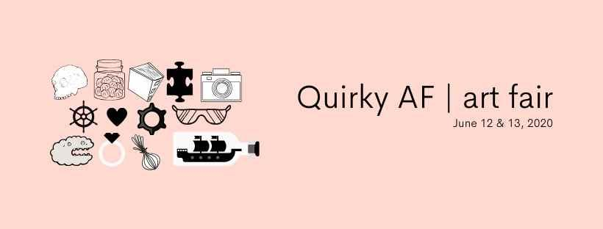

Application Information
Quirky AF | art fair 2020

Date: Friday, June 12 (during Art Crawl), 6-11 pm
Saturday, June 13, 10 am -3 pm
Location: Hamilton Artists Inc., 155 James St. N. Hamilton ON, L8R 2K9

Hamilton Artists Inc. is pleased to announce its second ever Quirky AF | art fair, a curated pop-up art, craft and design market that hosts talented and avant-garde makers. Hamilton Artists Inc. aims to be a destination for critical, unconventional, and challenging contemporary art practices that contribute to regional and national discourses. As such, the aim of this event is to bring together crafters and designers from across the region, who challenge expectations and take risks with work that is unconventional, experimental, political, or all-around weird and quirky.

To apply, please submit a completed application by March 5th 2020 at midnight to events@theinc.ca including:

- Application Form (located at the end of this document)
- Support images: 3-5 jpeg images of your work + links to your website and social media for review.
- Product Descriptions: Tell us about the work you intend to sell. How was it made? What makes it unique? What are the price points? These descriptions will help us market your work as we advertise the event.
- Biography (150 words): Tell us about yourself and your practice. This information may be used to market the event.
Please attach as a separate word doc. or PDF.

The Details
Quirky AF | art fair will feature the very weirdest in jewellery, paper/ prints, ceramics, toys, clothing, accessories, housewares and apothecaries from artisans from Hamilton and the surrounding regions. Located at Hamilton Artists Inc. at the corner of James and Cannon, Quirky AF | art fair will be open to the public during the Art Crawl weekend.

As a nonprofit artist run centre, with charitable status, Hamilton Artists Inc. heavily relies on annual fundraising. Revenues support gallery programs and operations.
Quirky AF | art fair 2020 Application Form

Contact Information:
1. Name and Company Name (if applicable):
2. Website:
3. Social Media:
4. Mailing Address:
5. Email:
6. Phone Number:

About You and Your Work (please attach as a separate word doc. or PDF).
1. Provide a detailed description of what you create. Be sure to include how you are quirky, avant-garde or experimental! (250 word max)
2. Briefly, list the type of goods you sell. (i.e. jewellery, children's apparel, etc.)
3. Indicate price range of goods.
4. For promotional use, please provide a 150 word max. biography.
5. Attach 3-5 digital images of your work. Use separate jpgs and keep files under 500k. Be sure to include details for each image here or as part of the title.

5. Logo? Send it too!
6. Would you prefer a full table ($100) □ or half-table ($60) □ (Please tick one)
7. How did you find out about Quirky AF | art fair?
8. A) A limited number of subsidized tables are available. Subsidized tables will be assigned on a first come-first served basis to folks experiencing financial barriers. Is there a financial barrier that prevents you from participating in Quirky AF | art fair? (Optional)
YES □
B) Please share any comments regarding your financial barrier. (Optional)
9. Is there anything else you would like to tell us (set up requirements, etc)?

Acceptance & Payment

1. I have read and understand the details.
YES□
2. I agree to process my payment via paypal or cheque 10 days after acceptance.
YES□
Please make cheques payable to Hamilton Artists Inc.
3. I agree to present and sell the same goods as described in my application.
YES□

